[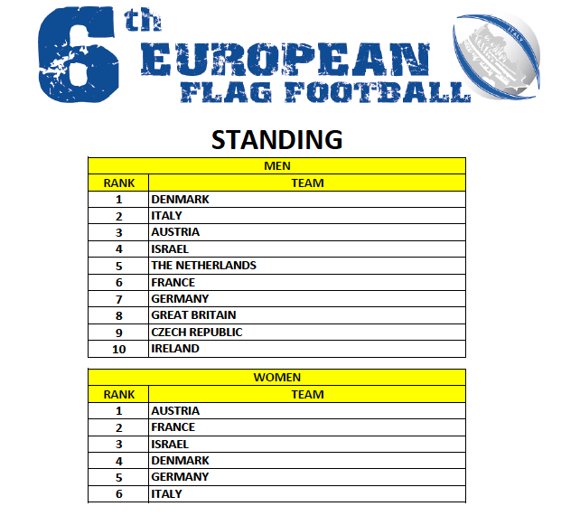](http://www.europeiflag2013.it/wp-content/uploads/2013/09/Standing.png)